1.**pwd** :

Pwd prints the full name of the current working directory

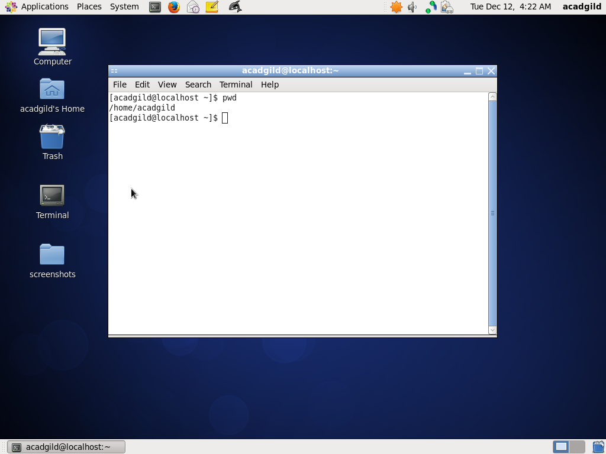

2.**vi :**

**vi is an interactive text editor which is display-oriented: the screen of your**[**terminal**](https://www.computerhope.com/jargon/t/terminal.htm)**acts as a window into the file you are editing.**

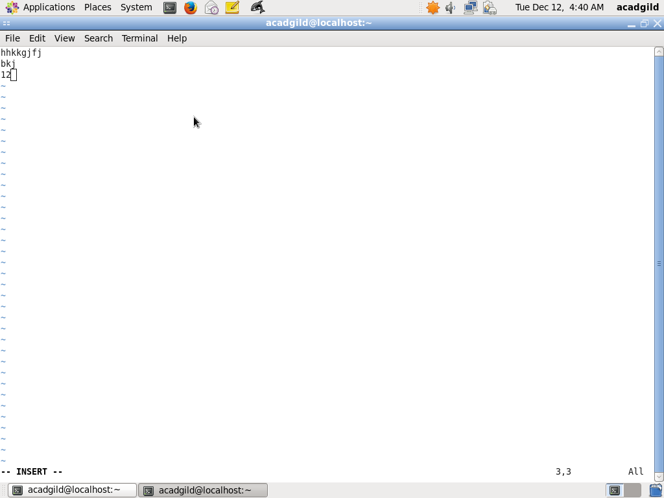 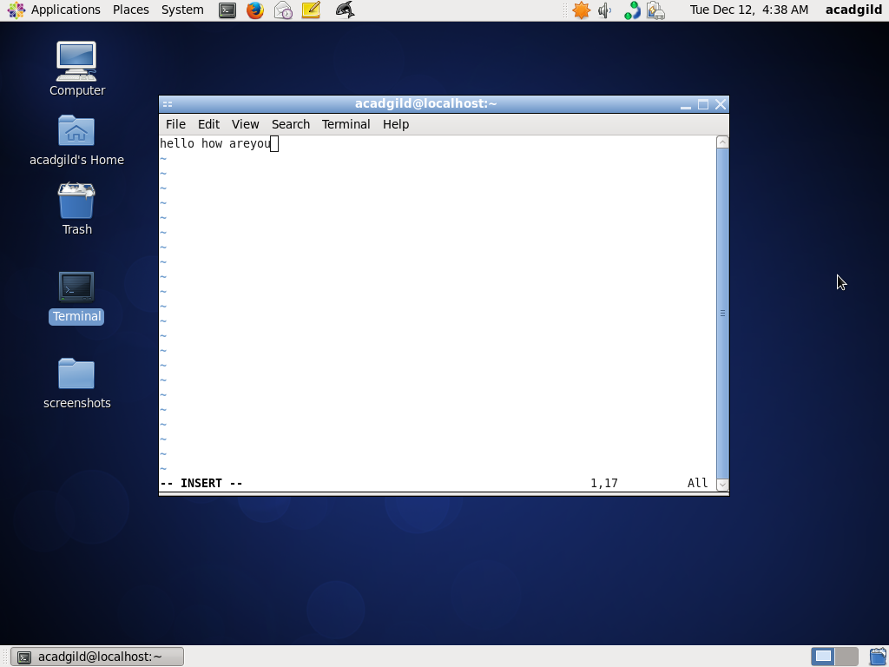

3. touch

**touch** changes file timestamps. It is also an easy way to create empty files.

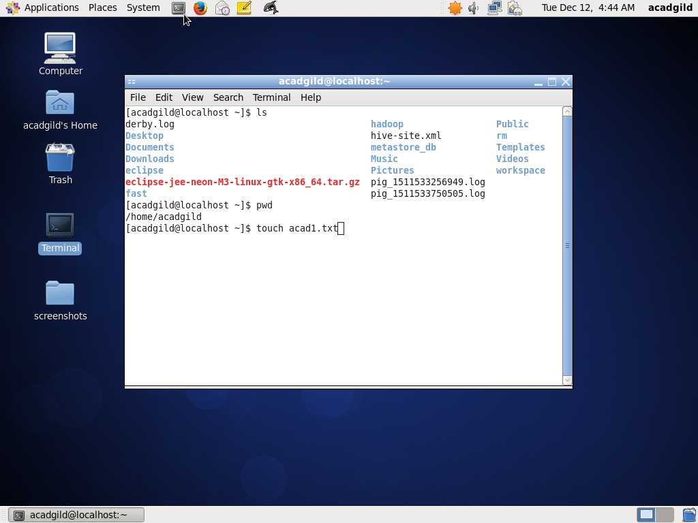

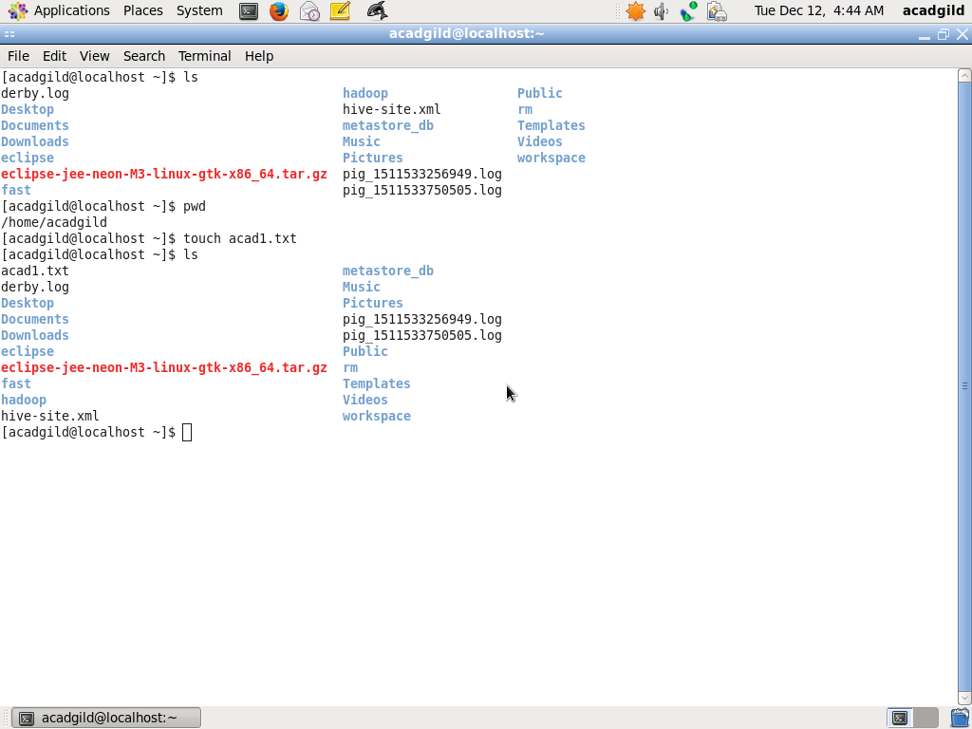

4. mkdir

Mkdir command creates new directories in the file system.If the secified directory does not already exist , mkdir creates it.

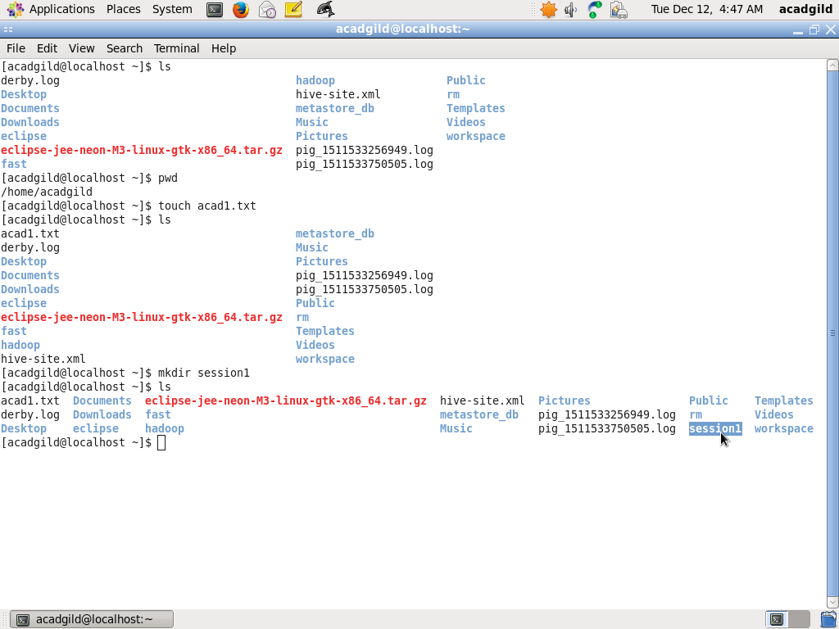

4. Mkdir -p : Creates a parent directory as necessary . when this option is specified , no error is reported if a directory already exists.

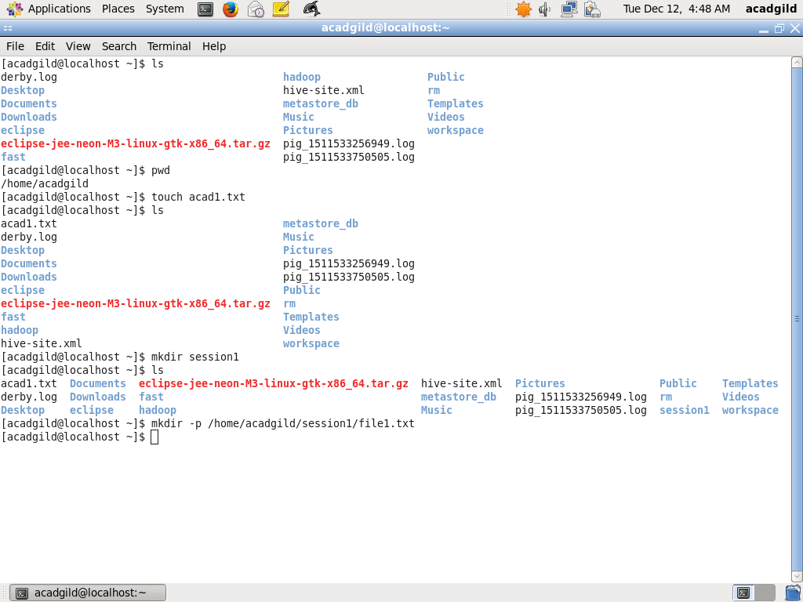



5. **RM :**

Rm command removed(deletes) the files or directories . **rm** removes each specified FILE. By default, it does not remove directories;

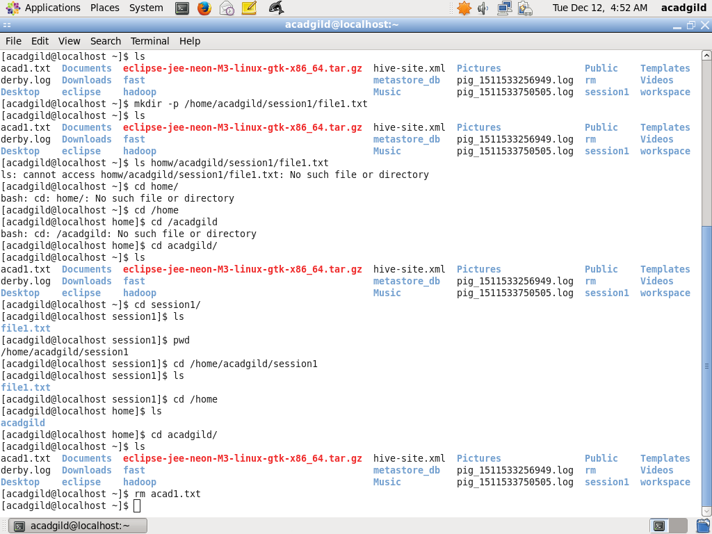

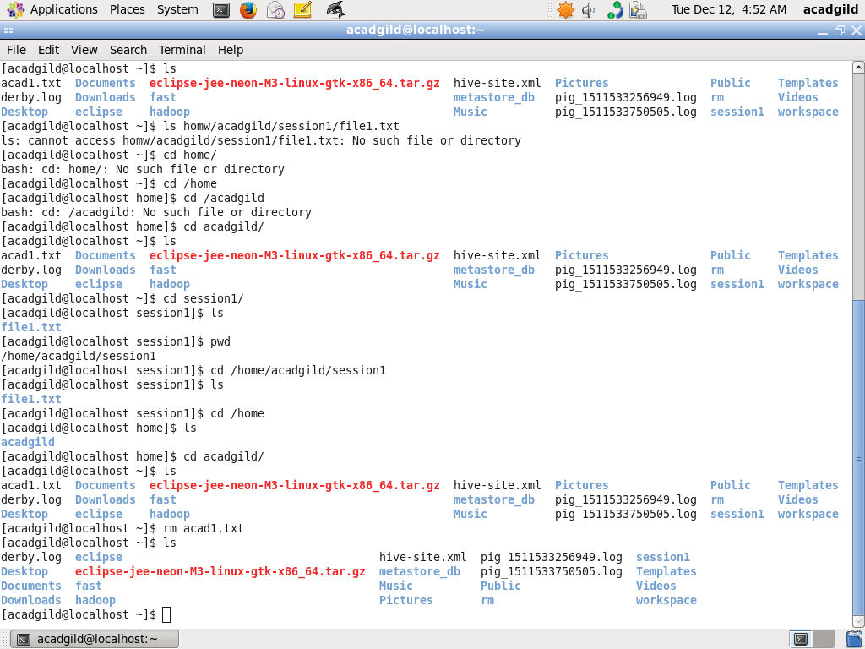

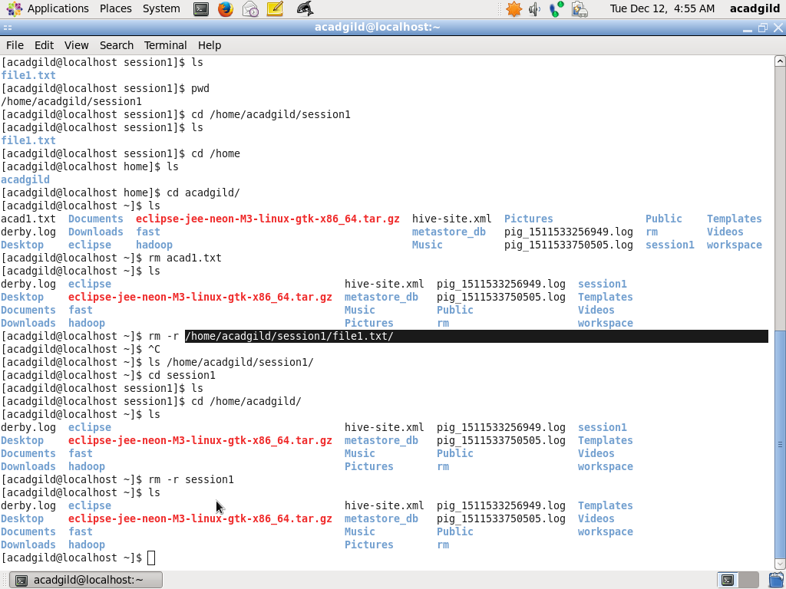

6. **LS :**

LS command list files and directories within the current working directory, allowing admins to see when configuration files were last edited.

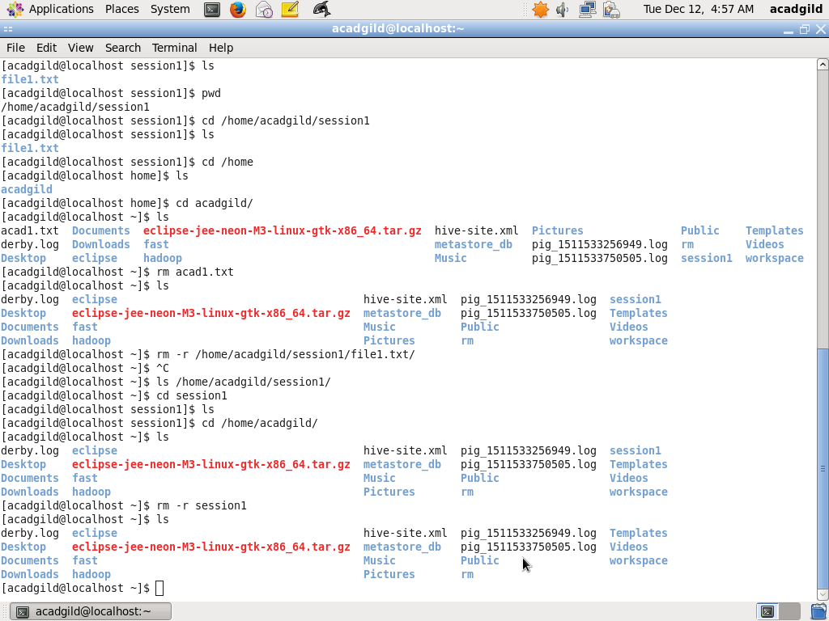

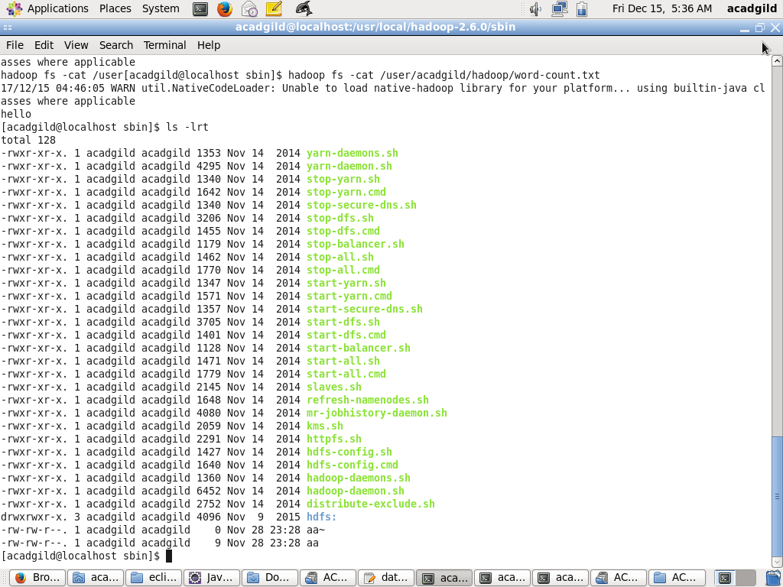

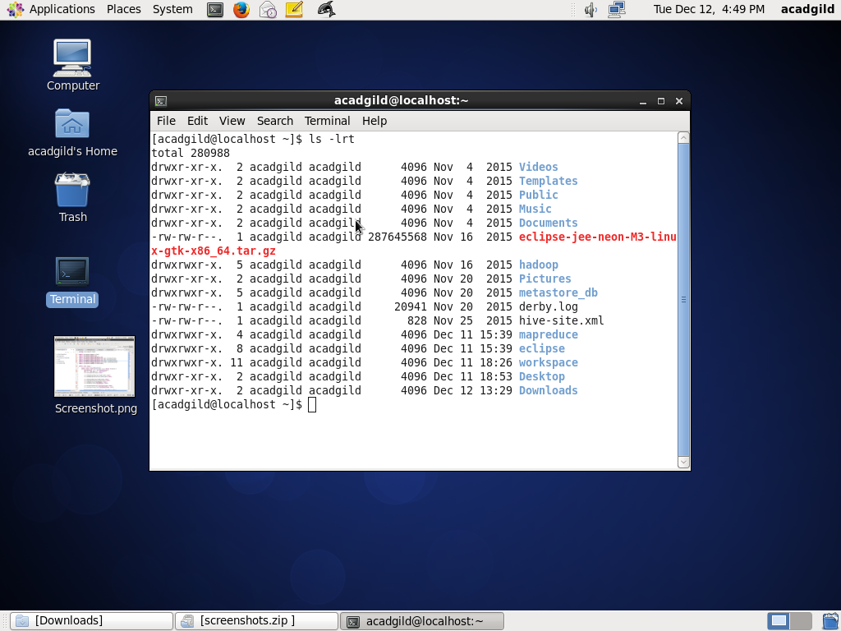

7. echo :

Echo allows a user to repeat , or “echo” , a string variable to standard output .

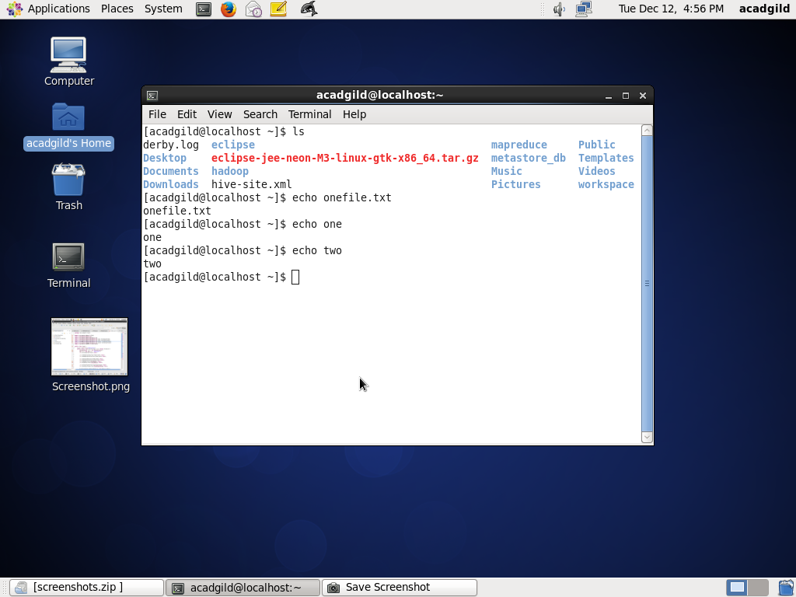

8. cat :

Cat is a command used to read , modify or concatenate text files . Cat commands are mostly used for displaying the contents of the file.

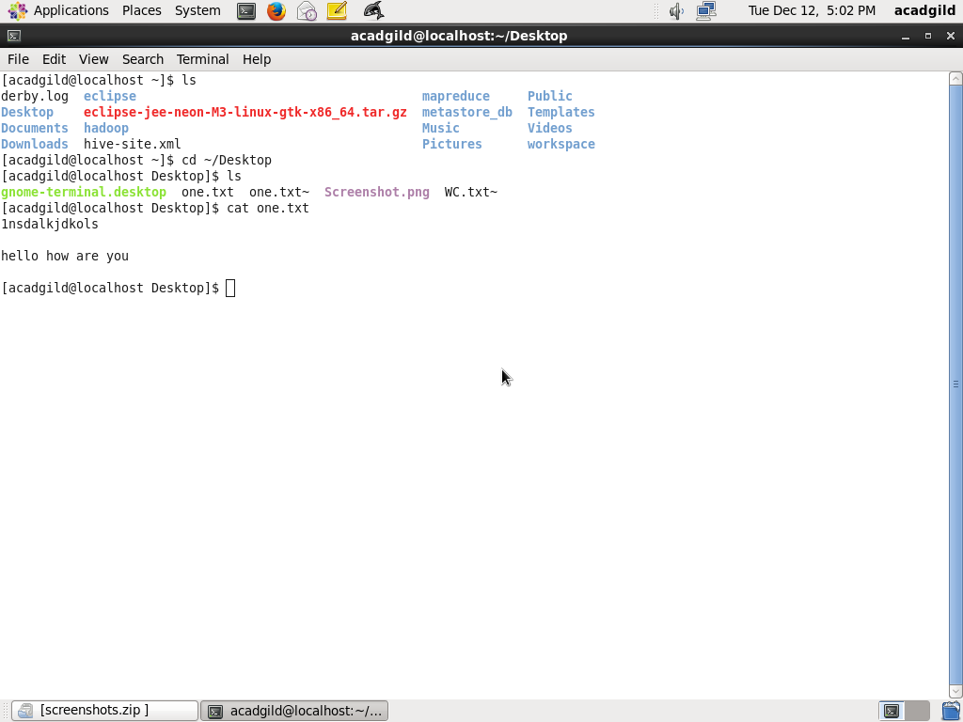

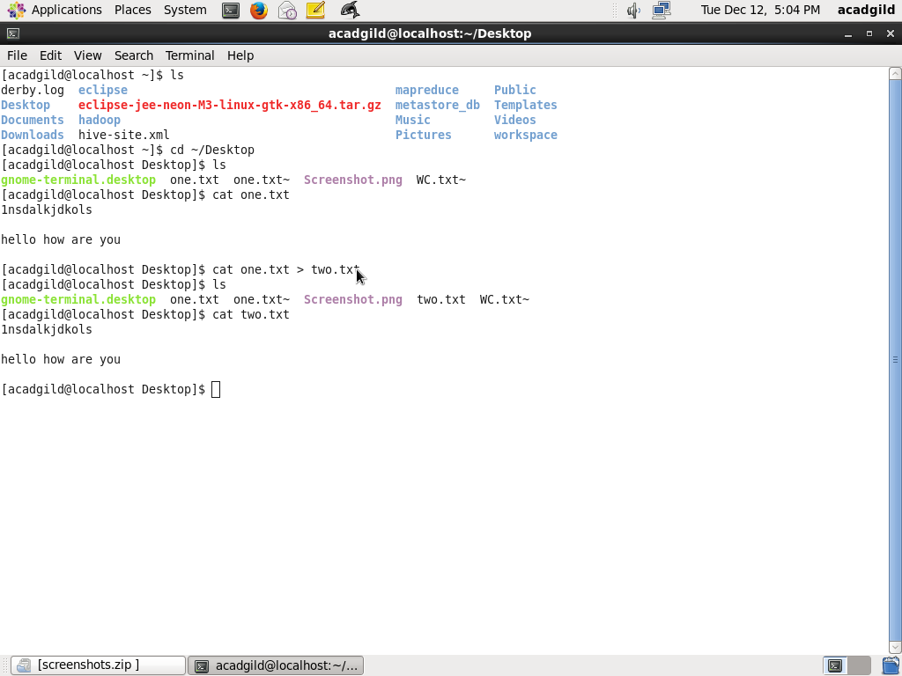

9. who :

The who command prints information about all users who are currently logged in.

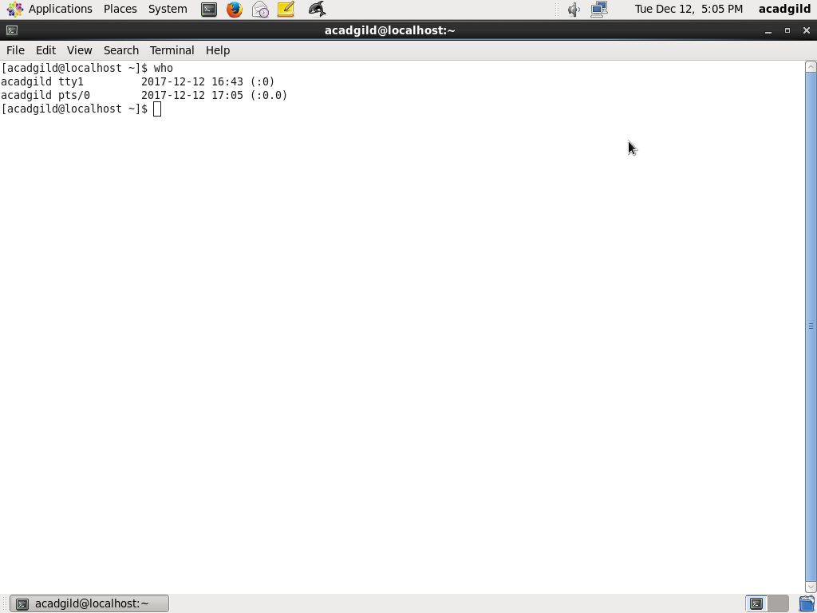

**10 : cd**

**The cd command changes the current directory in linux and toggle between directories conveniently.**

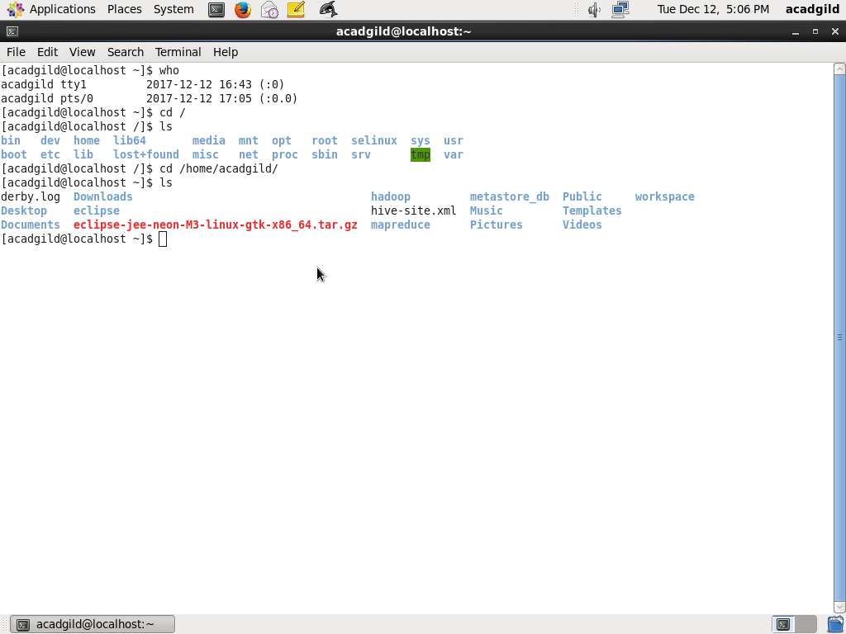

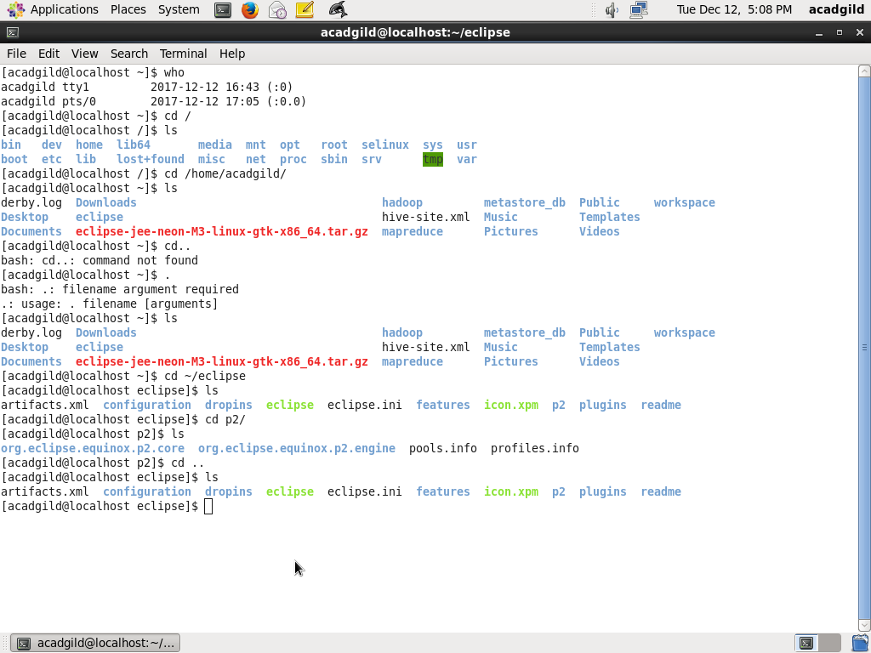

**11 date**

**The date command is used to print the value of the system time and information.**

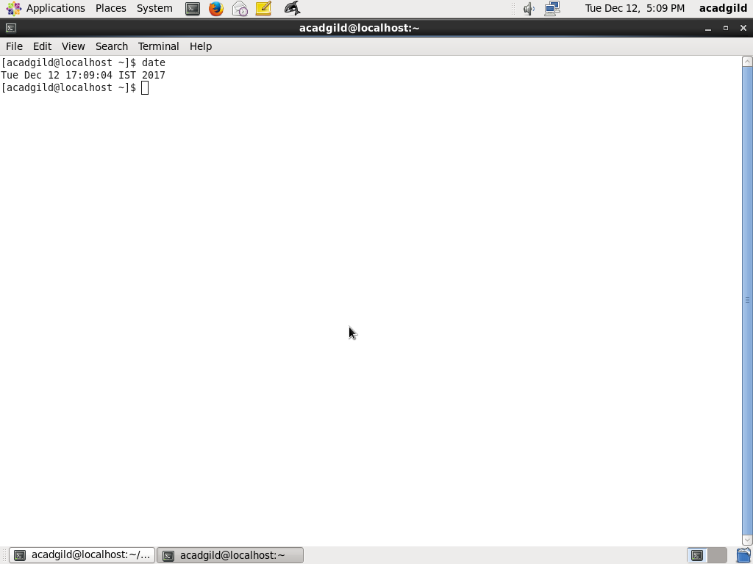

**12. CAL :**

**The cal command displays a simple , formatted calendar from the command line.**

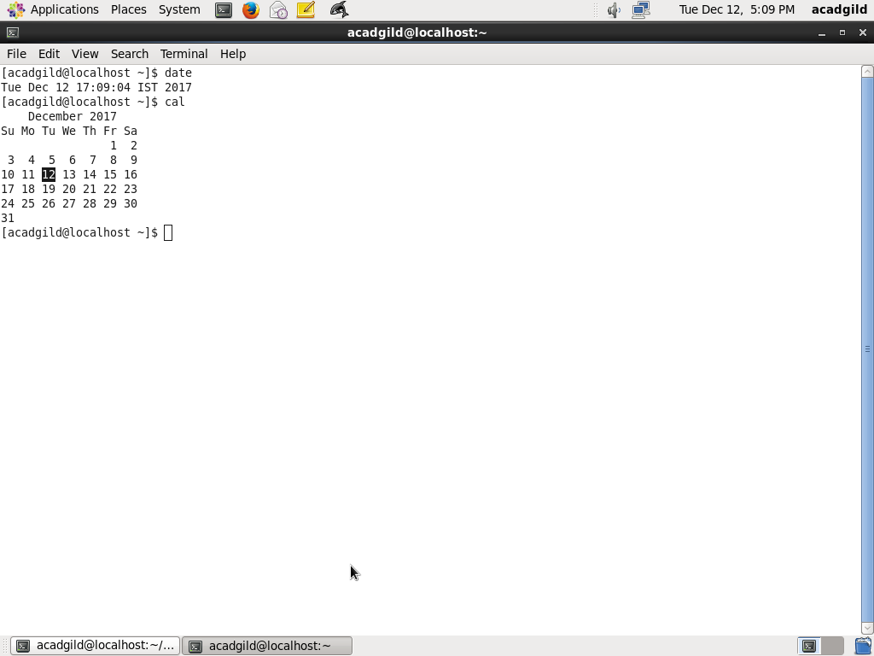

**13. MV**

**The mv command moves files and directories on the filesystem.**

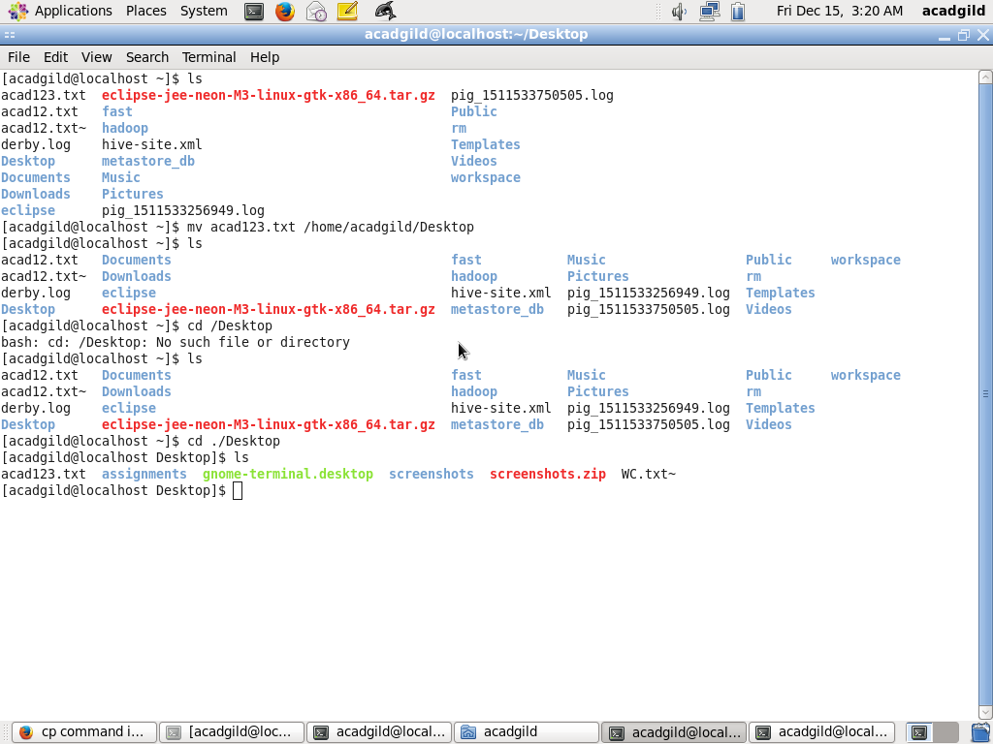

**14. CP**

**The mv command copies files and directories on the filesystem. .**



**15. which**

**Which command returns the pathnames of the filename** 